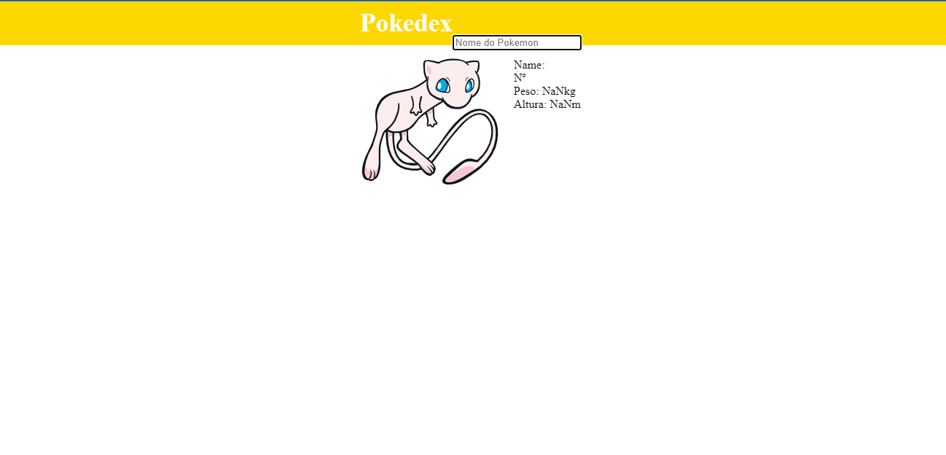

import { useState, useEffect } from "react";

import "./style.css";

function App() {

  const [pokemon, setPokemon] = useState([]);

  const [img, setImg] = useState("");

  const [nomePokemon, setNomePokemon] = useState("");

  function loadAPI() {

    let url = `https://pokeapi.co/api/v2/pokemon/${nomePokemon}`;

    fetch(url)

      .then((response) => response.json())

      .then((res) => {

        console.log(res);

        setPokemon(res);

        setImg(res.sprites.other.dream_world.front_default);

      })

      .catch((err) => console.log(err));

  }

  useEffect(() => {

    loadAPI();

  });

  return (

    <div className="container">

      <header>

        <strong>Pokedex</strong>

        <div>

          <br></br>

        <form>

          <input placeholder="Nome do Pokemon"

          onChange={(e) => setNomePokemon(e.target.value)}

          />

        </form>

      </div>

      </header>

      <br></br>

      <div class="flex-container">

        <div class="flex-child magenta">

          <img src={img} alt={pokemon.name} />

        </div>

        <div class="flex-child green">

          <div>Name: {pokemon.name}</div>

          <div>Nº {pokemon.id}</div>

          <div>Peso: {pokemon.weight / 10}kg</div>

          <div>Altura: {pokemon.height / 10}m</div>

        </div>

      </div>

    </div>

  );

}

export default App;